**ACKNOWLEDGEMENT**

The satisfaction that accompanies the successful completion of this project would be incomplete without mentioning the people who made it possible, without whose constant guidance and encouragement would have made efforts go in vain. I consider myself privileged to express gratitude and respect towards all those who have guided through the completion of projects.

I convey thanks to my project guide **Mr. Taral Contractor**, Computer Engineering/Artificial Intelligence & Data Science department, CGPIT for providing encouragement, constant support, and guidance which was of great help in completing this project work successfully.

I am grateful to my external guide **Mr. Ronak Rathwa, CTO** in **SPRIERS** for giving me the support and encouragement that was necessary for the completion of this project.

I am grateful to **Dr. Vibha Patel**, Head of the Department, Computer Engineering/Artificial Intelligence & Data Science department, CGPIT for giving us the support and encouragement that was necessary for the completion of this project.

I would also like to express my gratitude to **Prof. B. M. Vadher**, Director, Chhotubhai Gopalbhai Patel Institute of Technology for providing us congenial environment to work in.

I would like to thank all the faculty members for their patience, understanding and guidance that gave me strength and will power to work through the long tedious hours for developing a project and preparing the report.

Last but not the least, I would also like to thank my colleagues, who have co-operated during the preparation of our report and without them this project has not been possible. Their ideas helped me a lot to improve my project report.

**Vishva B More ( 202103103510447)**

**Abstract**

*Customer Relationship Management (CRM) systems play a crucial role in modern businesses by streamlining interactions with customers, managing sales pipelines, and improving overall efficiency. This project presents a full-stack CRM solution developed using* ***Next.js, Node.js, Express.js, MongoDB, and Passport.js****, offering a secure and user-friendly platform for managing customer data and business processes.*

*The CRM system is designed to handle various business needs, such as lead management, customer communication, sales tracking, and performance analytics. The backend is built using* ***Node.js and Express.js****, ensuring a robust and scalable API architecture.* ***MongoDB*** *serves as the database, providing a flexible schema to store and retrieve customer data efficiently.* ***Passport.js*** *is integrated for authentication, enabling secure login with multiple authentication strategies, including Google OAuth and traditional credentials.*

*On the frontend,* ***Next.js*** *is used to create a dynamic and responsive user interface. The framework's server-side rendering (SSR) and static generation capabilities enhance performance and improve SEO. UI components are developed using* ***Material UI, Next UI, and Shadcn UI****, ensuring a clean and intuitive user experience.*

*- Mr. Taral Contractor(Guide)*

*- Ms. Vibha Patel (HOD)*

*- Prof. B.M. Vadher (Director)*

***Vishva More (202103103510447)***

TABLE OF CONTENTS

Acknowledgements v

Abstract vi

List of Figures ix

List of Tables x

Chapter 1 Introduction 1

1.1 Overview 1

1.2 Problem Definition 1

1.3 Scope/Application 1

Chapter 2 Training Activities 2

Chapter 3 System Planning 3

3.1 Project Development Approach 3

3.2 System Modules 3

3.2.1 Module 1 3

3.2.2 Module 2 3

3.3 Functional Requirements 3

3.4 Non Functional Requirements 3

3.5 Timeline Chart 4

Chapter 4 System Design 5

4.1 Use Case Diagram 5

4.2 Sequence Diagram 5

4.3 Activity Diagram 5

4.4 Class Diagram 5

4.5 Database Schema 6

4.6 Data Flow Diagram 6

4.7 ER Diagram 6

Chapter 5 Implementation and Testing 7

5.1 Hardware and Software Requirements 7

5.2 Snapshots 7

5.3 Test Cases 7

Chapter 6 Conclusion and Future Scope 9

References 10

# List of Figures

Figure 3.1 Sample Timeline Chart 4

Figure 5.1 Home Page 7

# List of Tables

Table 4.1 Login Table 6

Table 5.1 Test Cases 7

**Guidelines to Prepare the Report**

* The first two pages must be in color print out.

| **Details** | **Font Type** | **Font size** | | **Alignment/Spacing** | |
| --- | --- | --- | --- | --- | --- |
| Chapter headings with chapter number on top  (Ex. Chapter 1 Introduction) | Times New Roman | 16pt bold capitals | | Right | |
| Section headings  (Ex. 1.1) | Times New Roman | 14pt bold capitalize each word | | Left Align | |
| Subsection headings  (Ex. 1.1.1) | Times New Roman | 12pt bold/ Italic  capitalize each word | | Left Align | |
| Body of report | Times New Roman | 12 pt | | Adjusted on both left and right (i.e. Justified) and with 1.5 spacing for text. | |
| Figures and Tables | Caption | | | | |
| Times New Roman | 10 pt. | | Centered | |
| Example :  For chapter 1 (figure/table numbering 1.1,1.2 onwards)  For chapter 2 (figure/table numbering 2.1,2.2 onward) | |
| **Figure Caption** must be **below** the figure and centered,  **Table caption** must be **above** the table and centered. | | | | |
| Page Numbering | Times New Roman | 12 pt. | | Right | |
| From “ACKNOWLEDGEMENTS to LIST OF FIGURES”: in Roman Letters (**starting from V, VI, etc.(Depends on page from title to certificate)**)  For Remaining Pages: (i.e. from CHAPTERS -to-REFERENCES: 1, 2, …… N) | | | | |
| **NO PAGE NUMBER SHOULD BE GIVEN TO COVER PAGE, CERTIFICATE PAGE, COMPANY CERTIFICATE and PROFILE PAGE** | | | | |
| HEADER | Times New Roman | 12 pt | | Right Align (Industrial Training Report) | |
| **APPLY HEADER FROM INTRODUCTION PAGE** | | | | |
| FOOTER | Times New Roman | 12 pt | | Page Number : Right Align | |
| **APPLY FOOTER FROM ACKNOWLEDGMENT**  **PAGE** | | | | |
| Margin | Left | | | | ${1.2}^{"}$ |
| Right | | | | $1^{"}$ |
| Bottom | | | | $1^{"}$ |
| Top | | | | $1^{"}$ |
| Line Spacing | Chapter Name | | **Three** line spacing **after** Chapter Name | | |
| Section and Sub Section Heading | | Add **one** line Space **Before** section/Sub Section Name | | |
| Body Content | | 1.5 spacing for text | | |
| Equation | | **One** Spacing **before and after** Equation | | |

# Introduction

## Overview

The **Customer Relationship Management (CRM) System** is a full-stack web application designed to help businesses manage customer interactions, track sales pipelines, and streamline internal workflows. Developed using **Next.js, Node.js, Express.js, MongoDB, and Passport.js**, this CRM ensures a secure and scalable environment for handling customer data. The backend, built with **Node.js and Express.js**, provides robust API services, while **MongoDB** serves as a flexible NoSQL database for efficient data storage. **Passport.js** is integrated for user authentication, supporting both **Google OAuth and traditional login methods**. The frontend, developed with **Next.js**, leverages **Material UI, Next UI, and Shadcn UI** to deliver an intuitive and responsive user experience. The system includes essential CRM features such as **customer data management, sales tracking, task assignment, and real-time dashboards** to provide actionable insights. Role-based access control ensures that different user levels (admin, manager, employee) have appropriate permissions, securing sensitive business data. The CRM allows businesses to store and update customer records, monitor sales progress, and assign tasks efficiently. The dashboard displays **interactive analytics and performance metrics**, helping organizations make data-driven decisions. By integrating modern web technologies and best practices, this CRM offers a **scalable, secure, and user-friendly** solution that enhances customer engagement and business productivity.

## Problem Definition

Managing customer relationships efficiently is a major challenge for businesses, especially small and medium-sized enterprises. Traditional methods like spreadsheets and manual record-keeping lead to **data redundancy, loss, and poor collaboration**, making it difficult to track customer interactions and sales pipelines effectively. Existing CRM solutions are often **costly and complex**, limiting their accessibility. To address these issues, this project introduces a **full-stack CRM system** built with **Next.js, Node.js, Express.js, MongoDB, and Passport.js**. It provides **secure authentication, customer data management, sales tracking, task assignment, and real-time analytics**, enabling businesses to streamline operations, improve productivity, and make data-driven decisions.

## Scope/Application

### Scope of the CRM Project

The **CRM system** is designed to help businesses efficiently manage customer relationships, track sales, and improve internal workflows. It provides a **centralized platform** for storing customer data, monitoring interactions, and assigning tasks to team members. The project scope includes **secure authentication, role-based access control, sales pipeline tracking, task management, and real-time analytics**.

The system will be implemented using **Next.js, Node.js, Express.js, MongoDB, and Passport.js**, ensuring scalability and performance. The **frontend** will offer a user-friendly interface with **Material UI, Next UI, and Shadcn UI**, making navigation intuitive. The **backend API** will handle data processing, user authentication, and business logic, while **MongoDB** will store customer records securely.

The CRM is **suitable for small to medium-sized businesses**, providing a cost-effective solution for managing customer interactions and sales workflows. Users will be able to **add, update, and delete customer records, track deals, assign tasks, and generate reports** to improve decision-making. Role-based access control will ensure that **admins, managers, and employees** have appropriate permissions to protect sensitive data.

Future enhancements may include **AI-driven insights, automation features, third-party integrations (such as email and payment gateways), and mobile application support**. This CRM aims to streamline business operations, improve customer engagement, and help organizations make **data-driven decisions for growth and efficiency**.

# Training activities

### TECHNOLOGIES LEARNED

During the training, I gained hands-on experience with various technologies essential for building a full-stack web application. The key technologies used in this CRM project are:

#### 2.1 Frontend Technologies

* **Next.js** – A React framework for server-side rendering (SSR) and static site generation (SSG), improving performance and SEO.
* **Material UI, Next UI, Shadcn UI** – Modern UI libraries for designing responsive and user-friendly interfaces.
* **React Hooks** – Managing state and side effects in a functional component-based structure.
* **Axios/Fetch API** – Handling API requests efficiently for data fetching.

#### 2.2 Backend Technologies

* **Node.js** – A JavaScript runtime used for server-side development.
* **Express.js** – A lightweight and fast web framework for building RESTful APIs.
* **MongoDB** – A NoSQL database for storing dynamic customer data.
* **Mongoose** – An ODM (Object Data Modeling) library for MongoDB, simplifying database interactions.
* **Passport.js** – Authentication middleware supporting Google OAuth and email-password login.
* **JWT (JSON Web Token)** – Used for secure authentication and authorization.

#### 2.3 Deployment & DevOps

* **Vercel** – Used for deploying the Next.js frontend.
* **Render/Heroku** – For deploying the backend API.
* **Git & GitHub** – Version control and collaborative development.

# System Planning

## Project Development Approach

Each project need to be developed with software model which makes the project with high quality, reliable and cost effective.

* Name of the software model
* Explain your software model
* Justify: Why you have selected this model for your project?
* Advantages of your software model

## System Modules

Overhere, briefly explain modules of your project. And also explain their role.

### Module 1

Overhere, briefly explain module 1 of your project. And also explain their role.

### Module 2

Overhere, briefly explain module 2 of your project. And also explain their role.

## Functional Requirements

Write down the same functional requirement you have written in your SRS.

## Non Functional Requirements

Write down the same non functional requirement you have written in your SRS.

## Timeline Chart

| **ACTIVITY** | **1 JULY-31 AUG** | **1 SEP-31 OCT** | **1 NOV-31 DEC** | **1 JAN-29 FEB** | **1 MARCH-10 MAY** |
| --- | --- | --- | --- | --- | --- |
| **Requirement Analysis** |  |  |  |  |  |
| **Designing** |  |  |  |  |  |
| **Implementation** |  |  |  |  |  |
| **Testing** |  |  |  |  |  |
| **Report Generation** |  |  |  |  |  |

**Figure 3.1 Sample Timeline Chart**

# System Design

## Use Case Diagram

Add brief introduction of your diagram as well as your diagram.

## Sequence Diagram

Add brief introduction of your diagram as well as your diagram.

## Activity Diagram

Add brief introduction of your diagram as well as your diagram.

## Class Diagram

Add brief introduction of your diagram as well as your diagram.

## Database Schema

List out all the tables that you have used in your project.

Eg.

**Table 4.1 Login Table**

| **Column Name** | **Data Type** | **Size** | **Constraint** | **Description** |
| --- | --- | --- | --- | --- |
| **Id** | INT | 50 | Primary Key | ID No. |
| **UserName** | VARCHAR | 50 | --- | Username |
| **UserEmail** | VARCHAR | 50 | --- | Useremail |
| **Password** | VARCHAR | 50 | --- | Password |

**Table 4.2 Lead Table**

| **Column Name** | **Data Type** | **Size** | **Constraint** | **Description** |
| --- | --- | --- | --- | --- |
| **Id** | INT | 50 | Primary Key | ID No. |
| **CompanyName** | VARCHAR | 50 | --- | Companyname |
| **CustomerName** | VARCHAR | 50 | --- | Customername |
| **Email** | VARCHAR | 50 | --- | email |
| **Address** | VARCHAR | 50 | --- | address |
| **ProductName** | VARCHAR | 50 | --- | Productname |
| **Amount** | INT | 50 | --- | Amount |
| **GstNumber** | VARCHAR | 50 | --- | Gstnumber |
| **Status** | VARCHAR | 50 | --- | Status |
| **Date** | DATE | 50 | --- | Date |
| **EndDate** | DATE | 50 | --- | Enddate |
| **Notes** | VARCHAR | 50 | --- | Notes |

## Data Flow Diagram

Add brief introduction of your diagram as well as your diagram.

## ER Diagram

Add brief introduction of your diagram as well as your diagram.

# Implementation and testing

## Hardware and Software Requirements

Detailed description of hardware and software used in your project.

## Snapshots

* **Home Page**

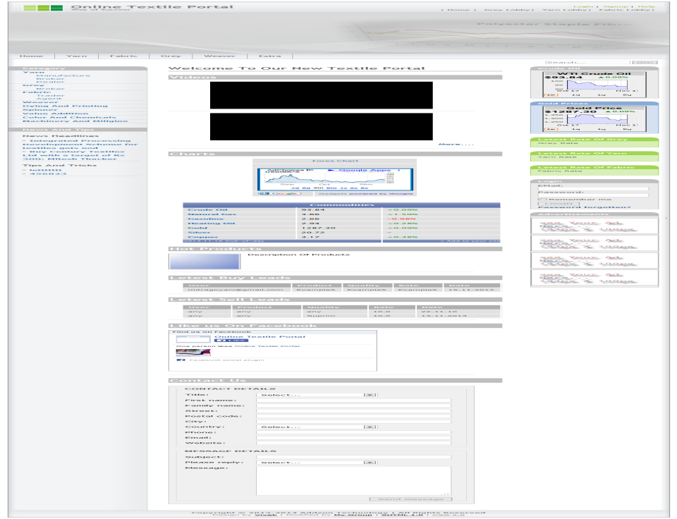

**Figure 5.1 Home Page**

Add description of your screen layout. You have to add all screen layouts along with the description of your project.

## Test Cases

Sample test cases are given as below in :

**Table 5.1 Test Cases**

| **TestID** | **Case** | **Test Data** | **Expected Result** | **Actual Result** | **Pass/Fail** |
| --- | --- | --- | --- | --- | --- |
| 1 | Login | - Internet Connectivity  - Login ID  - Password | If Login ID & password is empty or invalid and No Internet connectivity then dispay Error message otherwise  login sucessfully | If Login ID & password is empty or invalid and no Internet connectivity then dispay error message. | Pass |
| 2 | Home  (Networth) | Swipe down  For Synchronization | First time Synchronization  When swipe down,  Networth report will refresh. | First time Synchronized.  When swipe down,  Networth report refreshed. | Pass |
| 3 | Reports | Select given inputs for particular reports. | Display report as per selection of inputs. | Report displayed as per selection of inputs. | Pass |
| 4 | Forgot password | Email Id | If email-id is valid & authorized then new password is set by received email. | Password is reset if the email-id is authorized and valid. | Pass |
| 5 | Logout | Select logout | User should logout from the application and redirected to login page. | User logs out from the application and redirected to login page. | Pass |
| 6 | Exit | Select Exit | Application should be closed. | Application is closed. | Pass |

# Conclusion and Future Scope

Conclude your project work. Also discuss future enhancement of your project and/or how limitation of project can be removed if any. Don’t make sub topic of conclusion and future scope.

**References**

**Paper references**

List of authors seprated by comma, “title of paper”, jornoul / conference name, volume number, page number, month & year]

1. Vassilios S. Verykios, Ahmed K. Elmagarmid, Bertino Elisa, Yucel Saygin, and Dasseni Elena, "Association Rule Hiding," IEEE Transactions on Knowledge and Data Engineering ,pp.23-27, May 2003.

**Book references**

Author(s),”Chapter title”in book title, edition,volume.Editors name,Ed. Publishing location: Publicaton Company,year

1. C. W. Lander, Power Electronics, 3d. ed. London: McGraw-Hill, 1993.

**Web references**

[Online]Complete URL [Date Accessed].

1. [Online][http://www.franchisemart.in/business-services-franchise/online-textile portal-franchise/](http://www.franchisemart.in/business-services-franchise/online-textile-portal-franchise/) [Date Accessed: 25 OCT 2015].